**Naan Mudhalvan Assignment**

*Sanjogitha Balakrishnan*

*E38852A5D70B7FAB25B421A51CD465F2*

[*www.linkedin.com/in/sanjogitha*](http://www.linkedin.com/in/sanjogitha)

*SMART BOOK*

[*https://www.facebook.com/profile.php?id=61550630362*](https://www.facebook.com/profile.php?id=61550630362)

[*https://sansmartbook.blogspot.com/p/smart-book.html*](https://sansmartbook.blogspot.com/p/smart-book.html)

[*https://sansmartbook.blogspot.com/2023/09/smart-book.html*](https://sansmartbook.blogspot.com/2023/09/smart-book.html)

[*https://sansmartbook.blogspot.com/2023/09/blog-post.html*](https://sansmartbook.blogspot.com/2023/09/blog-post.html)

*G-V5LXNRXB6C*

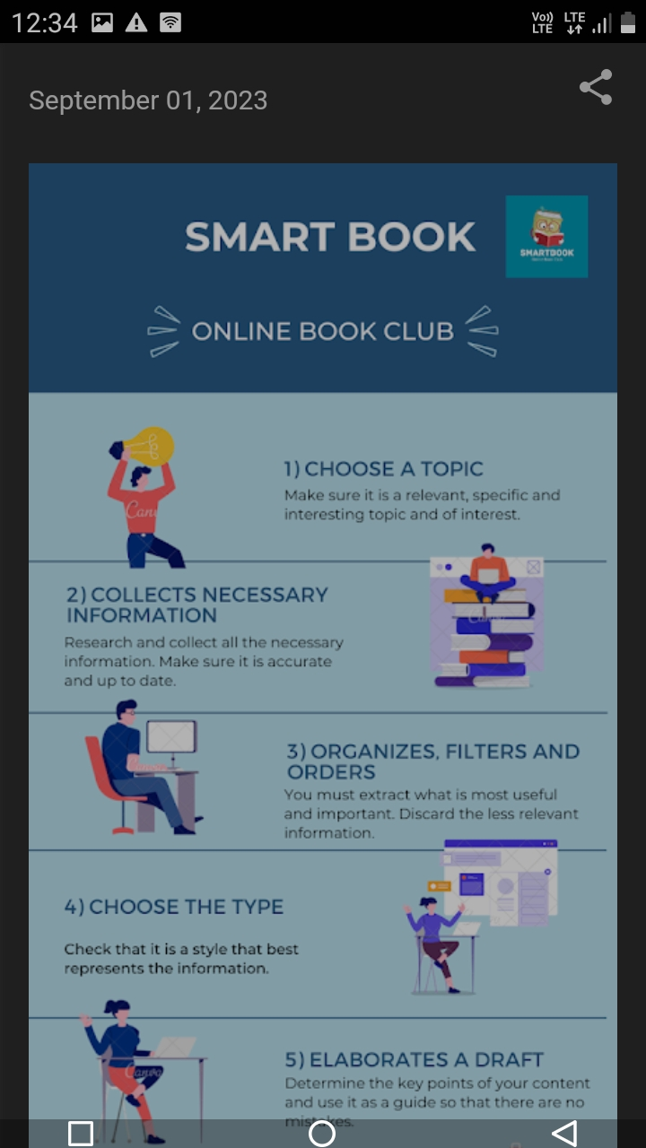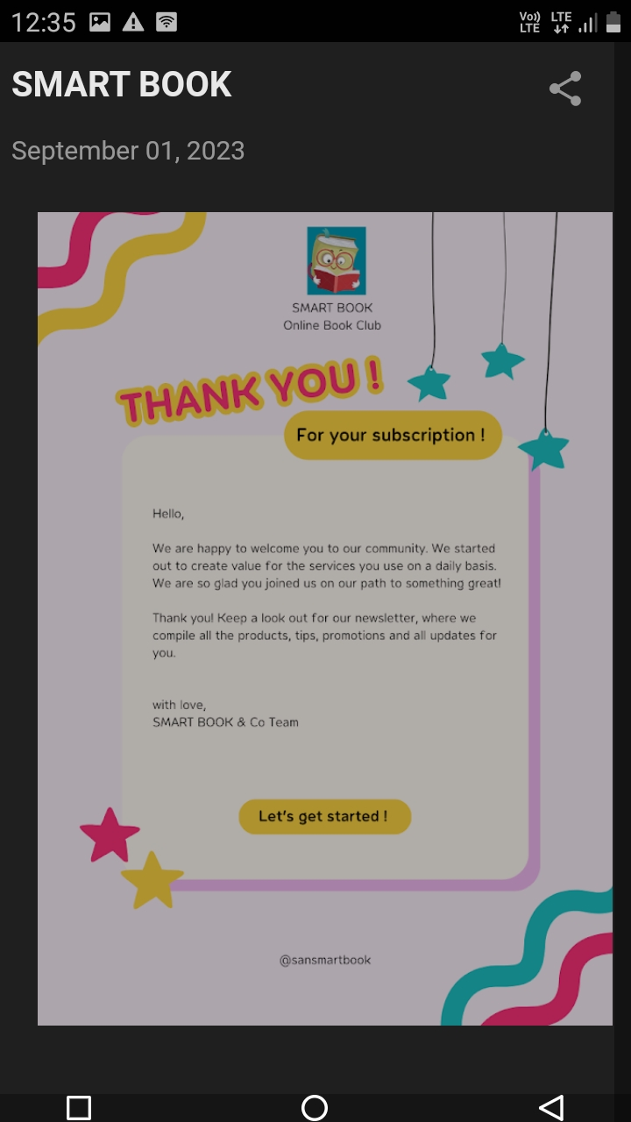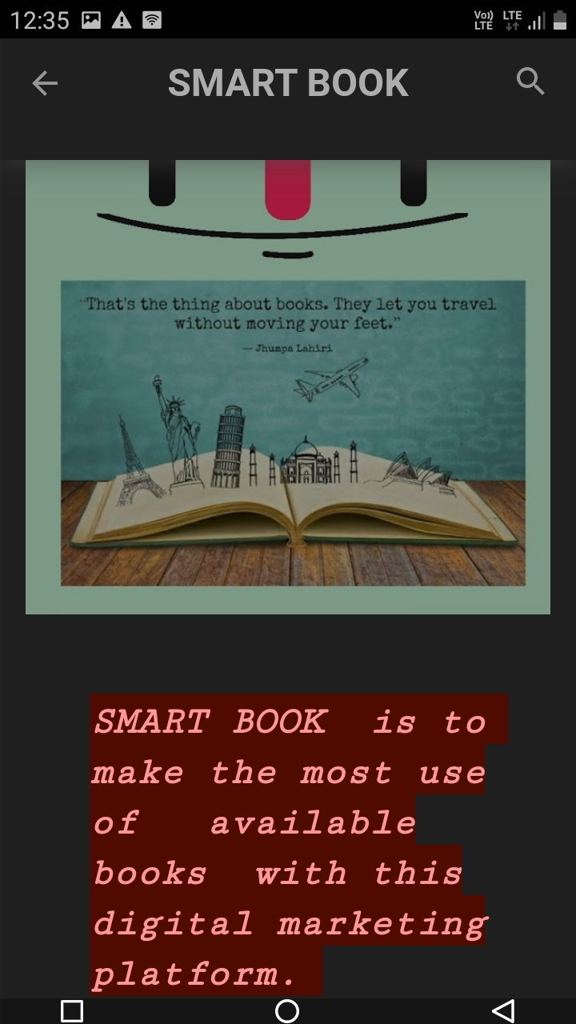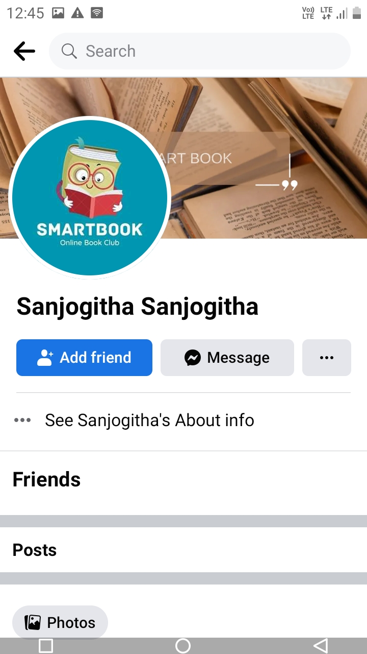

**Summary**

*Learnt Digital Marketing in a satisfactory manner. Blogging was a thing which could be learnt in a free time or at a boredom period but that is finished at the right time as it is.*

***THANK YOU***